

STAREHE GIRLS’ 2025 PREDICTION
POSSIBLE KCSE EXAM
121/2
MATHEMATICS
PAPER 2
TIME: 2½ HOURS

NAME……………………………………………………………………………………….
SCHOOL……………………………………………… SIGN………………………..
INDEX NO……………………………………………. ADM NO……………………

(Kenya Certificate of Secondary Education)
INSTRUCTIONS TO CANDIDATES
- Write your name, index number and date in the spaces provided at the top of this page.
- Write name, admission number and class in the spaces provided above.
- This paper contains TWO sections: section I and section II
- Answer ALL the questions in Section I and only five questions from section II.
- Show all the steps in your calculations, giving your answers at each stage in the spaces provided below each question.
- Marks may be given for correct working even if the answer is wrong.
- Non-programmable silent electronic calculators and KNEC mathematical tables may be used except where stated otherwise.

SECTION I (50 marks)
Answer all the questions in this section in spaces provided
- Use logarithms, correct to 4 decimal places, to evaluate (4mks)
$$\sqrt[3]{\frac{83.46x0.0054}{{1.52}^{2}}}$$

- Given that the ratio of x:y = 4:5, find to the simplest form the ratio of (7x-2y):(x+2y) (2mks)

- Ruto bought a plot of land for Ksh.280,000. After 4 years, the value of the plot was Ksh.495,000. Determine the rate of appreciation, per annum, correct to one decimal place. (3mks)

- The height in centimeters, of 100 tree seedlings in a tree nursery are shown in the table below.
Height(cm) | 10-19 | 20-29 | 30-39 | 40-49 | 50-59 | 60-69
Number of trees | 9 | 16 | 19 | 26 | 20 | 10
Find the quartile deviations of the heights. (3mks)

- The equation of a circle is given by 4x²-12x+4y²- 8y - 3= 0. Determine the coordinates of the centre of the circle and the radius of the circle. (4mks)

- Simplify the expression $\frac{\sqrt{48}}{\sqrt{5}+\sqrt{3}}$, leaving the answer in the form a$\sqrt{b}$ +c where a, b and c are integers (3mks)

- In the figure below R, T and S are points on a circle centre O. PQ is a tangent to the circle at T, POR is a straight line and <QPR = 20⁰.
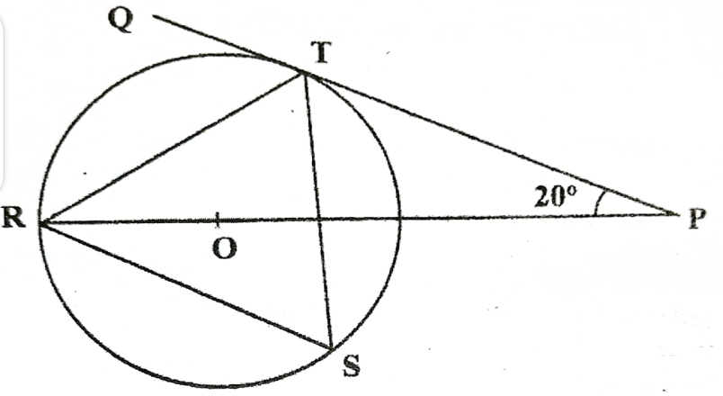
Giving reasons find the size of $<RST$ (2mks)

- a) Expand the expression ${\left(1+\frac{1}{2}x\right)}^{5}$ in ascending powers of x, leaving the coefficients as fraction in their simplest form. (2mks)

b) Use the first three terms of the expansion in (a) above to estimate the value of ${\left(1.05\right)}^{5}$
correct to 4 significant figures (2mks)

- Make t the subject of the formula in s = $\sqrt{\frac{3d(t−d)}{8}}$ (3mks)

- A trader bought maize for Ksh 20 per kilogram and beans for Ksh 60 per kilogram. She mixed the maize and beans and sold the mixture at Ksh 48 per kilogram. If she made a 60% profit, determine the ratio of maize:beans per kilogram in the mixture. (3mks)

- The cash price of a digital television is Ksh. 27,500. A customer decided to buy it on hire purchase terms by paying a deposit of Ksh 17,250. Determine the monthly rate of compound interest charged on the balance if the customer is required to repay by six equal monthly instalments of Ksh. 2,100 each. (3mks)

- The first, the third and the seventh terms of an increasing arithmetic progression are three consecutive terms of a geometric progression. If the first term of the arithmetic progression is 10, find the common difference of the arithmetic progression. (4mks)

- The lengths of two similar pieces of wood were given as 12.5 m and 9.23 m. Calculate the absolute error in calculating the difference in length between the two bars. (3mks)

- Solve for x given that $\frac{1}{3}\log_{2}8+\log_{2}\left(2x−4\right)=5$ (3mks)

- In nomination for a committee, two people were to be selected at random from a group of 3 men and 5 women. Find the probability that a man and a woman were selected. (2mks)

- Pipe A can fill an empty tank in 3 hours while, pipe B can fill the same tank in 6 hours. When the tank is full it can be emptied by pipe C in 8 hours. Pipe A and B are opened at the same time when the tank is empty. If one hour later, pipe C is opened, find the total time taken to fill the tank. (4mks)

SECTION II (50 marks)
Answer only five questions in this section in spaces provided
- The table below shows the income tax rates for a certain year.
Monthly taxable income in Ksh | Tax rate (%) in each shilling
1-11,180 | 10
11,181-21,714 | 15
21,715-32,248 | 20
32,249-42,782 | 25
Over 42,782 | 30
- During the year, Njuguna’s monthly income was as follows: Basic salary Ksh 40,000, House allowance Ksh 11,090 and Commuter allowance Ksh 7,000.
Calculate a) Njuguna’s total monthly taxable income. (1mk)

b) Total income tax charged on Njuguna’s monthly income (4mks)

- Njuguna’s net monthly tax was Ksh. 10,750.80. Determine the monthly tax relief allowed. (1mk)

- A proposal to expand the size of the first income tax band by 50% while retaining the size of the next three bands was made. The tax rates would remain as before in each band. Using the proposal, calculate:
- the tax Njuguna would pay in the first band. (2mk)

- the tax Njuguna would pay in the last tax band. (2mks)

- a) Given that A=$\left[\begin{matrix}3 & x \\ x+1 & 2\end{matrix}\right]$ and B=$\left[\begin{matrix}1 & 2 \\ 3 & 0\end{matrix}\right]$, find the values of x for which AB is a singular matrix. (3mks)

b) Otieno bought 3 exercise books and 5 pens for a total of Ksh 165. If Otieno had bought 2 exercise books and 4 pens, he would have spent Ksh 45 less. Taking letter e to represent the price of an exercise book and letter p to represent the price of a pen
- Form two equations to represent the above information. (2mks)

- Use matrix method to find the price of an exercise book and that of a pen. (3mks)

- The principal of Njabini boys decided to reward 36 students each with 2 exercise books and one pen. Calculate the total amount of money he paid. (2mks)

- Three quantities X, Y and Z are such that X varies directly as the square root of Y and inversely as the fourth root of Z. When X=64, Y=16 and Z= 625.
- Determine the equation connecting X, Y and Z. (4mks)

- Find the value of Z when Y=36 and X=160 (2mks)

- Find the percentage change in X when Y is increased by 44% and Z decreased by 19% correct to one decimal place. (4mks)

- The figure below shows a parallelogram OPQR with O as the origin, OP = p and OR= r. Point T divides RQ in the ratio 1:4. PT meets OQ at S.
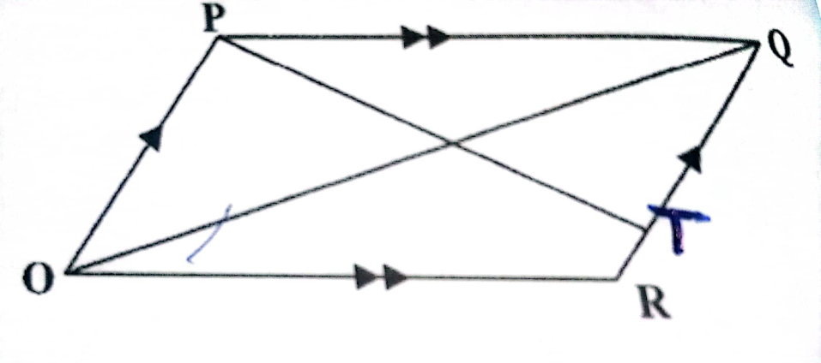
- Express in terms of p and r the vectors
- OQ (1mk)

- OT (1mk)

- Vector OS can be expressed in two ways; i) OS= mOQ ii) OS= OT + nTP, where m and n are constants. Express OS in terms of
- m, p and r (1mk)

- n, p and r (1mk)

Hence find the
- value of n and m (5mks)

- ratio OS:SQ (1mk)

- A quadrilateral ABCD has vertices at A(1,1), B(4,2), C(1,3), D(2,2).
- Draw ABCD on the grid provided (1mk)
- Give that X=$\left[\begin{matrix}1 & 0 \\ 0 & −1\end{matrix}\right]$ Y=$\left[\begin{matrix}−1 & 0 \\ 0 & 1\end{matrix}\right]$ V=$\left[\begin{matrix}0 & −1 \\ −1 & 0\end{matrix}\right]$. Find the coordinates of A¹B¹C¹D¹, A¹¹B¹¹C¹¹D¹¹ and A¹¹¹B¹¹¹C¹¹¹D¹¹¹ the images of ABCD under combined transformation VXY. Show all your working of coordinates below;
- Coordinates of A¹B¹C¹D¹ and draw it on the grid. (2mks)

- Coordinates of A¹¹B¹¹C¹¹D¹¹ and draw it on the grid. (2mks)

- Coordinates of A¹¹¹B¹¹¹C¹¹¹D¹¹¹ and draw it on the grid. (2mks)

- Showing your working find a single matrix that will map ABCD onto A¹¹¹B¹¹¹C¹¹¹D¹¹¹. (3mks)

- a) Complete the table below for ${y=x}^{3}$+4$x^{2}−$5x$−$5 (2mks)
X | -5 | -4 | -3 | -2 | -1 | 0 | 1 | 2
${y=x}^{3}$+4$x^{2}−$5x$−$5 |  |  | 19 |  |  | -5

- On the grid provided, draw the graph of ${y=x}^{3}$+4$x^{2}−$5x -5 for -5 ≤ x ≤ 2 (3mks)

- i) Use the graph to solve the equation $x^{3}$+ 4$x^{2}−$5x - 5 = 0 (2mks)

ii) By drawing a suitable straight line graph, solve the equation
$x^{3}$+4$x^{2}−$x-4 = 0 (3mks)

- A polytechnic planned to buy $x$ lockers for a total cost of Ksh 16,200. The supplier agreed to offer a discount of Ksh 60 per locker. The polytechnic was then able to get three extra lockers for the same amount of money.
- Write an expression in terms of $x$, for the:
- Original price of each locker; (1mk)

- Price of each locker after the discount. (1mk)

- Form an equation in $x$ and hence determine the number of lockers the polytechnic bought. (5mks)

- Calculate the discount offered to the polytechnic as a percentage (3mks)

- i) Using ruler and compasses only construct triangle ABC such that AB=4 cm, BC= 5cm and <ABC=120⁰. (3mks)

ii) Measure AC (1mk)
iii) On the same diagram draw a locus of points equidistant from point A and point C and label the locus as $L_{1}$. (1mk)

iv) Draw on the same diagram a locus of points $L_{2}$ equidistant from point C and point B and lable the locus as $L_{2}$ (1mk)
v) label the point where $L_{1} and L_{2}$ meet as O. Using O as a centre draw a locus of points $L_{3}$ touching points A, B and C. Measure the length from point O to $L_{3}$. (2mks)
vi) Draw the locus of points $L_{4}$ equidistant from line AC and Line AB. Extend $L_{4}$ to meet line BC and lable where they meet point D. Measure the length AD. (2mks)

